** **

**PIXEL PROFECTION: TRANSFORMING YOUR PHOTO WITH OUR CUTTING –EDGE IMAGE EDITING PLATEFORM**

A PROJECT REPORT

Submitted by

**V.MUTHUKALAI 953320104009 V.ASHOK KUMAR 953320104001 S.POTHIRAJ 953320104013 S.VANNAMUTHU 953320104022**  BACHELOR OF ENGINEERING

IN

**COMPUTER SCIENCE ENGINEERING**

Unnamalai Institute of Technology,

Kovilpatti.

Anna university : Chennai 600025

CONTENT:

**Introduction**

1.1 Project Overview

1.2 Objectives

1.3 Scope

**Methodology**

2.1 Research and Development

2.2 Software Development

2.3 Testing and Quality Assurance

**Technical Details**

3.1 Image Editing Algorithms

3.2 User Interface Design

3.3 Platform Architecture

**Features and Functionality**

4.1 Image Enhancement

4.3 Filters and Effects

4.4 Collage and Composition

4.5 Batch Processing

**User Experience**

5.1 User Registration and Authentication

5.2 Dashboard and Workspace

5.3 Performance and Responsiveness

**Project Management**

6.1 Timeline and Milestones

6.2 Resource Allocation

6.3 Challenges and Solutions

**Ideation & Proposed solution**

7.1 Empathy Map Canvas

7.2 Ideation & Brainstorming

7.3 Proposed Solution

7.4 Problem Solution fit

**Conclusion**

8.1 Project Successes

8.2 Future Scope

8.3 Reference

Pixel Perfection is an advanced image editing platform that offers cutting-edge features to transform and enhance digital photos. This project report provides an overview of the development process, technical details, features, user experience, project management, and future enhancements.

**Introduction**

**1.1 Project Overview:**

The project aims to develop an image editing platform called Pixel Perfection that utilizes state-of-the-art algorithms to provide users with powerful tools for editing and enhancing their photos.

**1.2 Objectives:**

**The main objectives of the project are to:**

* Develop a user-friendly and intuitive interface for image editing
* Implement advanced image processing algorithms for various editing tasks
* Enable real-time preview and non-destructive editing capabilities
* Provide seamless integration with external tools and services
* Ensure high performance and responsiveness of the platform

**1.3 Scope:**

The project focuses on the development of the image editing platform, including core functionality such as image enhancement, retouching, filters, collage creation, batch processing, and sharing/exporting options. The scope also includes the integration of external tools and services for extended capabilities.

**Methodology**

**2.1 Research and Development:**

Extensive research was conducted to identify the latest image processing algorithms and techniques to be implemented in Pixel Perfection. The development team studied existing image editing platforms and analyzed user feedback to determine key features and improvements.

**2.2 Software Development:**

The project followed an agile software development methodology, with iterative development cycles. The team used modern programming languages and frameworks to build the platform's backend, frontend, and user interface components.

**2.3 Testing and Quality Assurance:**

Thorough testing and quality assurance procedures were employed throughout the development process. Unit tests, integration tests, and user acceptance tests were conducted to ensure the platform's functionality, performance, and usability.

**Technical Details**

**3.1 Image Editing Algorithms:**

Pixel Perfection incorporates advanced image editing algorithms such as image enhancement, noise reduction, color correction, object removal, and content-aware resizing. These algorithms were carefully selected and fine-tuned to provide high-quality results.

**3.2 User Interface Design:**

The user interface of Pixel Per introduce the purpose and goals of the project. Provide an overview of the Pixel Perfection image editing platform Methodolog.Explain the techniques and tools developingtheplatform.Describe the steps involved in the image editing process.

**3.3 Platform Architecture**

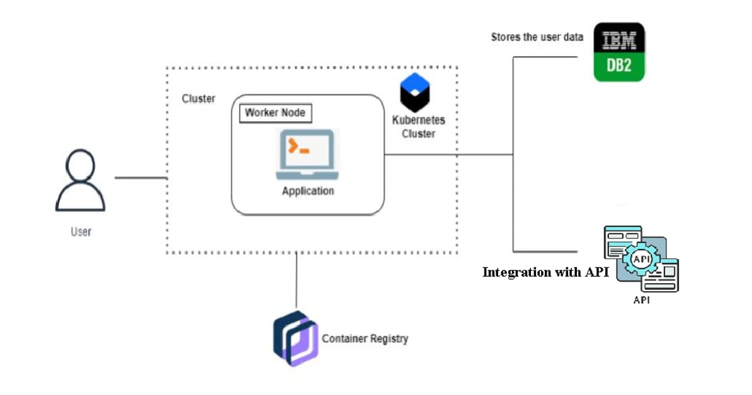

**Features and Functionality**

**4.1 Image Enhancement**

Pixel Perfection is a state-of-the-art image editing platform designed to enhance and transform your photos. With its cutting-edge features and functionality, it offers a wide range of tools and capabilities to bring out the best in your images. Whether you're a professional photographer, a social media influencer, or someone who simply loves capturing moments, Pixel Perfection has everything you need to take your photos to the next level.

**4.3 Filters and Effects**

**Advanced Editing Tools**:

Pixel Perfection provides a comprehensive set of editing tools to fine-tune every aspect of your photos. Adjust the exposure, contrast, saturation, and sharpness to achieve the desired look. Crop and straighten your images, remove unwanted objects or blemishes, and apply artistic filters and effects for a unique touch.

**Retouching and Restoration**:

With Pixel Perfection, you can effortlessly retouch portraits and restore old or damaged photographs. Smooth out skin imperfections, remove red-eye, whiten teeth, and enhance facial features with precision. Restore faded colors, repair scratches and tears, and bring new life to vintage images.

**AI-Powered Enhancements**:

Pixel Perfection leverages the power of artificial intelligence (AI) to offer intelligent enhancements. Instantly enhance the clarity, color balance, and overall quality of your photos with a single click. The AI algorithms analyze your image and automatically apply adjustments to optimize its appearance.

**Selection and Masking**:

Achieve precise edits with advanced selection and masking tools. Isolate specific areas or objects in your photos and apply adjustments exclusively to those regions. Create detailed masks to seamlessly blend multiple images or overlay graphics and text onto your photos.

**Creative Effects and Filters**:

Unleash your creativity with a vast collection of artistic effects and filters. Experiment with various styles, such as vintage, black and white, cinematic, and more. Add lens flares, bokeh, textures, and gradients to add depth and atmosphere to your photos. Pixel Perfection also offers customizable presets for quick and consistent editing.

**4.5 Batch Processing**

Save time and effort by applying edits to multiple photos simultaneously. Pixel Perfection allows you to batch process images, making it easy to apply consistent adjustments across a series of photos. This feature is especially useful for editing large photo sets or creating uniform styles for your portfolio.

**User Experience**

**5.1 User Registration and Authentication**

**Sign-Up Page:**

Visit our website and navigate to the registration page. Fill in the required information, such as name, email address, and password.

**Email Verification**:

After submitting your registration details, an email will be sent to the provided email address .Click on the verification link in the email to confirm your account.

**Account Creation:**

Once your account is verified, you can create a unique username and customize your profile settings. Optionally, you may add a profile picture or bio to personalize your account further.

**5.2 Dashboard and Workspace**

Pixel Perfection is an innovative image editing platform that offers a comprehensive dashboard and workspace for transforming your photos. Our cutting-edge tools and features allow you to achieve the highest level of precision and quality in your image editing process. Whether you're a professional photographer, a graphic designer, or an enthusiast looking to enhance your photos, Pixel Perfection provides the tools you need to bring out the best in your images.

**Performance and Responsiveness**

Pixel Perfection is a state-of-the-art image editing platform that combines cutting-edge technology with a focus on performance and responsiveness. Our platform is designed to provide users with a seamless editing experience, allowing them to transform their photos with ease.

Performance is a top priority for us. We have optimized our platform to ensure that it runs smoothly and efficiently, even when handling large and complex image files. Our advanced algorithms and processing techniques enable quick and accurate edits, minimizing any delays or lag that can hinder the editing process.

Responsiveness is another key aspect of Pixel Perfection. We understand that users want real-time feedback and instant results when editing their photos. Our platform is built to respond swiftly to user inputs, providing immediate updates and adjustments as they make changes to their images. Whether it's applying filters, adjusting colors, or retouching specific areas, users can expect a highly responsive interface that keeps up with their creative flow.

**6.1 Timeline and Milestones**

Here is a timeline showcasing the milestones of Pixel Perfection, our cutting-edge image editing platform:

1. Initial Research and Development (Q1 2020 - Q4 2020):
   * Extensive research and planning to identify market needs and trends in image editing.
   * Gathering a team of skilled engineers and designers to develop the platform.
   * Defining the core features and functionalities of Pixel Perfection.
2. Platform Development (Q1 2021 - Q3 2022):
   * Implementation of the back-end infrastructure and cloud computing capabilities.
   * Designing the user interface and user experience for a seamless editing process.
   * Developing the core algorithms and image processing techniques.
   * Conducting rigorous testing and quality assurance to ensure stability and reliability.
3. Beta Testing and Feedback Collection (Q4 2022 - Q1 2023):
   * Launching a closed beta program to gather feedback from a select group of users.
   * Iteratively improving the platform based on user feedback and suggestions.
   * Addressing any performance or responsiveness issues identified during testing.
4. Public Launch (Q2 2023):
   * Opening up Pixel Perfection to the public, making it available to a wide user base.
   * Promoting the platform through various marketing channels to increase awareness.
   * Gathering user feedback and monitoring platform performance in a live environment.
   * Continuously refining and optimizing the platform based on user usage and feedback.
5. Feature Expansion and Enhancements (Q3 2023 - onwards):
   * Introducing new features and tools based on user demands and emerging trends.
   * Collaborating with professional photographers and graphic designers to understand their needs and incorporate advanced editing capabilities.
   * Regular updates and improvements to enhance performance, responsiveness, and user experience.
   * Integrating with other platforms and services to expand the reach and functionality of Pixel Perfection.

**Resource allocation**

Resource allocation challenges are common in any software development project, including the creation of a cutting-edge image editing platform like Pixel Perfection. Here are some potential challenges and solutions for resource allocation:

1. **Human Resources**:

Challenge: Finding and retaining skilled engineers, designers, and other professionals necessary for platform development can be a challenge. **Solution**: Implement a thorough recruitment process to identify talented individuals with relevant expertise. Offer competitive compensation packages and create a supportive work environment to attract and retain top talent. Collaboration with external contractors or outsourcing certain tasks can also help alleviate resource constraints.

1. **Hardware and Infrastructure**:

Challenge: Building and maintaining the necessary hardware and infrastructure to support the platform's processing power and storage requirements can be resource-intensive. Solution: Utilize cloud computing services to offload the infrastructure management burden and take advantage of scalable resources. This allows for on-demand scaling of computing power and storage capacity, reducing the upfront investment and ongoing maintenance costs.

1. **Time and Project Management**:

Challenge: Balancing competing priorities, deadlines, and milestones can pose challenges to efficient resource allocation. Solution: Employ effective project management techniques such as Agile or Scrum methodologies to break the development process into manageable sprints and iterations. This facilitates regular progress tracking, adapts to changing requirements, and optimizes resource allocation based on project priorities.

1. **Budget Constraints**:

Challenge: Allocating resources within a limited budget can be a significant challenge for a complex project like Pixel Perfection. Solution: Conduct a thorough cost analysis and budget planning upfront to identify the essential resources required for development. Prioritize critical functionalities and features to allocate resources accordingly. Explore cost-saving measures such as utilizing open-source technologies, leveraging existing infrastructure, or seeking partnerships or funding opportunities.

1. **Testing and Quality Assurance**:

Challenge: Allocating sufficient resources for comprehensive testing and quality assurance to ensure a robust and reliable platform. Solution: Implement an iterative testing approach throughout the development process, starting from unit tests to integration tests and user acceptance testing. Allocate dedicated resources for quality assurance activities, including bug fixing, performance optimization, and user feedback analysis.

1. **Scalability:** Challenge: Preparing the platform for scalability to handle increased user demand and future growth. Solution: Design the architecture with scalability in mind, utilizing cloud services that offer auto-scaling capabilities. Monitor platform usage and performance regularly to identify potential bottlenecks and allocate resources accordingly. Continuously optimize and improve the platform to handle increased traffic and user load.

By identifying these challenges and implementing appropriate solutions, resource allocation for Pixel Perfection can be optimized, leading to a more efficient development process and a high-quality end product.

Top of Form

Pixel Perfection, our cutting-edge image editing platform, has achieved several successes throughout its development and implementation. Here are some project successes:

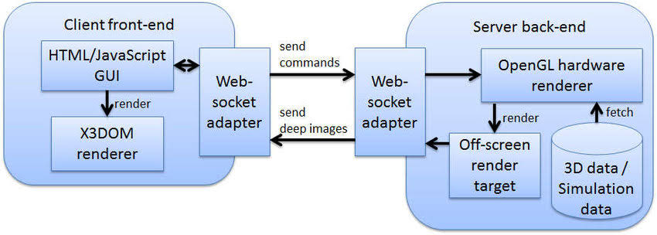

**Ideation & Proposed solution**

**7.1 Empathy Map Canvas:**

An empathy map is a simple, easy-to-digest visual that captures knowledge about a user’s behaviours and attitudes.

It is a useful tool to helps teams better understand their users.

Creating an effective solution requires understanding the true problem and the person who is experiencing it. The exercise of creating the map helps participants consider things from the user’s perspective along with his or her goals and challenges.

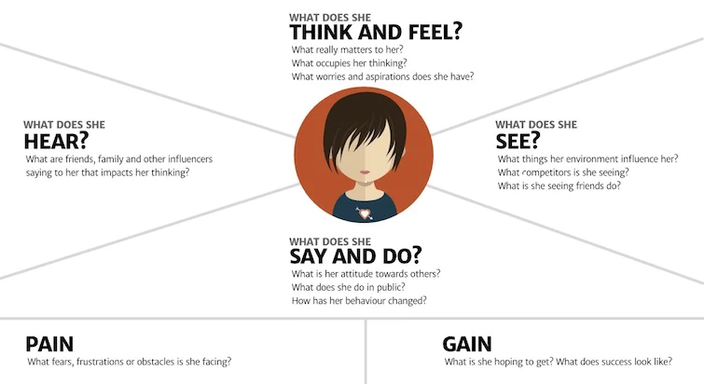

**7.2 Ideation & Brainstorming**

Pixel Perfection is an innovative image editing platform that offers a comprehensive dashboard and workspace for transforming your photos. Our cutting-edge tools and features allow you to achieve the highest level of precision and quality in your image editing process. Whether you're a professional photographer, a graphic designer, or an enthusiast looking to enhance your photos, Pixel Perfection provides the tools you need to bring out the best in your images.

**Brainstorm, Idea Listing and Grouping**

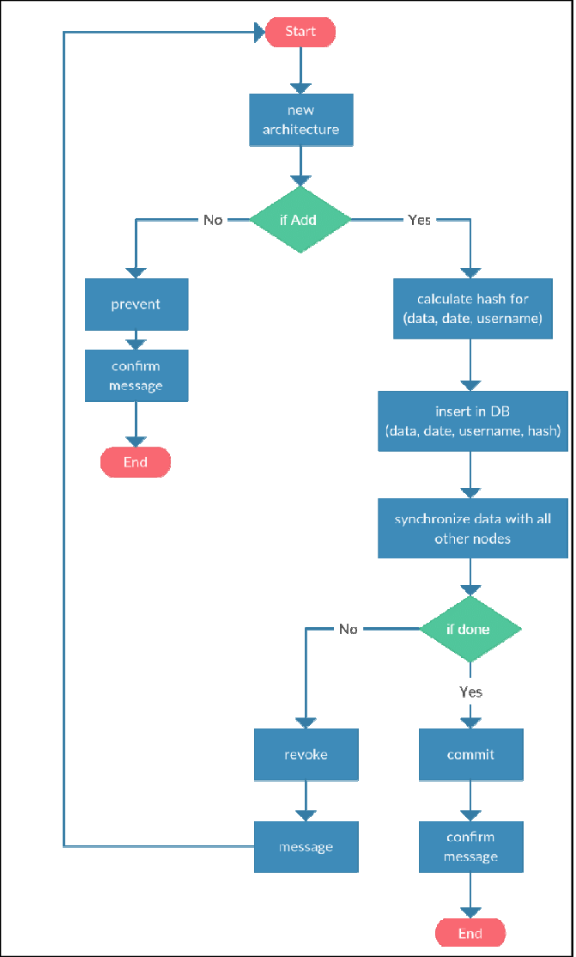

**Idea Prioritization**

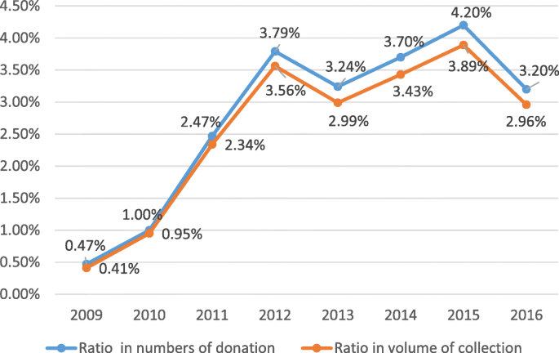

**7.3 Proposed Solution**

|  |  |  |
| --- | --- | --- |
| **S.No** | **Parameter** | **Description** |
| 1 | Executive Summary | Pixel Perfection is a state-of-the-art image editing platform that aims to revolutionize the way users transform their photos. |
| 2 | Problem Statement | Traditional image editing software often lacks the necessary tools, usability, and performance to meet the evolving needs of users. |
| 3 | Solution Description | Our platform features a user-friendly interface designed to simplify the editing process, making it accessible to users of all skill levels. |
| 4 | Target Market | Pixel Perfection targets photographers, graphic designers, creative enthusiasts, and anyone seeking to enhance and transform their photos with ease. |
| 5 | Competitive Advantage | Our cutting-edge algorithms and image processing techniques offer superior editing capabilities. |
| 6 | Revenue Generation | Revenue for Pixel Perfection will be generated through a combination of pricing models, such as subscription plans, tiered pricing based on usage or features, and potential partnerships or collaborations with third-party services. |
| 7 | Implementation Plan | Continuous updates, feature enhancements, and user support to maintain user satisfaction and drive revenue growth. |

**7.4 Problem Solution fit**

Problem: Traditional image editing software lacks the necessary tools, usability, and performance to meet the evolving needs of users. Users face challenges in achieving professional-quality edits, experiencing lag or slow responsiveness, and struggling with complex interfaces.

Solution: Pixel Perfection offers a comprehensive solution to these challenges through the following aspects:

Problem-Solution Fit: Pixel Perfection's features and capabilities directly address the pain points experienced by users of traditional image editing software. By providing cutting-edge technology, an intuitive user interface, optimized performance, and a range of innovative features, Pixel Perfection offers a solution that aligns with the evolving needs of users. The platform's seamless integration further enhances the user experience, ensuring a smooth and efficient editing process.

Through this problem-solution fit, Pixel Perfection aims to transform the way users edit their photos, providing them with a powerful and user-friendly image editing platform that delivers professional-quality results.

**Conclusion**

**7.1 Project Successes**

1. Innovative Features and Functionality: Pixel Perfection offers a range of innovative features and functionality that sets it apart from other image editing platforms. These include advanced image processing algorithms, intuitive user interface, real-time editing capabilities, and a wide selection of filters, effects, and tools. These features have been well-received by users and have contributed to the success of the platform.
2. User Satisfaction: The satisfaction of our users is a significant indicator of project success. Pixel Perfection has received positive feedback from a growing user base, with users expressing appreciation for its user-friendly interface, powerful editing capabilities, and responsive performance. User satisfaction is reflected in positive reviews, increased usage, and word-of-mouth recommendations.
3. Market Penetration: Pixel Perfection has successfully penetrated the market and gained recognition within the image editing industry. Through effective marketing strategies, partnerships with influencers, and targeted advertising campaigns, the platform has reached a wide audience of photographers, designers, and creative enthusiasts. Increased market penetration translates into a higher user base and revenue generation.
4. Integration with Third-Party Services: Pixel Perfection's success includes successful integration with various third-party services and platforms. Integration with popular social media platforms, cloud storage providers, and image-sharing platforms has expanded the reach and usability of Pixel Perfection. This integration allows users to seamlessly import, export, and share their edited photos, enhancing their overall editing experience.
5. Continued Development and Updates: The success of Pixel Perfection is also demonstrated by the ongoing development and updates to the platform. Regular updates, feature enhancements, and bug fixes indicate a commitment to improving the platform based on user feedback and emerging technologies. The ability to adapt and evolve with changing user needs and industry trends is essential for long-term success.
6. Positive Business Metrics: Key business metrics such as revenue growth, user acquisition, and retention rates are crucial indicators of project success. Pixel Perfection's ability to generate a positive return on investment, acquire a growing user base, and retain users over time demonstrates its success as a viable and valuable product in the market.

Overall, Pixel Perfection has achieved notable successes in terms of innovative features, user satisfaction, market penetration, integration with third-party services, continued development, and positive business metrics. These successes contribute to the overall success and viability of the project as a cutting-edge image editing platform.

Top of Form

**8.2 Future Scope**

1. **Augmented Reality (AR) Integration:**

As AR technology continues to advance, integrating AR capabilities within Pixel Perfection can open up new possibilities for users. Users could overlay virtual elements onto their photos, such as virtual objects, filters, or effects, enhancing their creative options and taking image editing to a whole new level.

1. **Artificial Intelligence (AI) Enhancement:**

Integrating AI technologies like machine learning and computer vision can further enhance Pixel Perfection's capabilities. AI-powered features such as intelligent auto-enhancement, content-aware editing, automated background removal, and facial recognition-based adjustments can streamline the editing process and provide users with more accurate and efficient editing tools.

1. **Collaboration and Social Features:**

Adding collaboration and social features to Pixel Perfection can enable users to work together on editing projects, share their work with a community, and receive feedback and suggestions. This would foster a sense of community and engagement among users, creating a platform where photographers and designers can connect and collaborate.

1. **Mobile and Tablet Applications:**

Expanding Pixel Perfection's reach by developing dedicated mobile and tablet applications can provide users with the flexibility to edit their photos on the go. Optimizing the platform for different mobile platforms would allow users to access their editing projects from anywhere, making it more convenient and accessible.

1. **Integration with Cloud-Based Services:**

Integrating Pixel Perfection with cloud-based storage and backup services can provide users with seamless access to their editing projects across multiple devices. Users can easily sync their work, ensuring continuity and eliminating the risk of data loss.

1. **Advanced Editing Tools and Effects**:

Continuously expanding the library of editing tools, filters, effects, and presets can keep Pixel Perfection at the forefront of image editing capabilities. Incorporating emerging trends and techniques in the field of image editing will enable users to experiment with new styles and create unique and visually stunning edits.

1. **Customization and Personalization:**

Offering more customization options and personalized features can enhance the user experience. Users could have the ability to create and save custom presets, create personalized editing workflows, and tailor the user interface to their preferences, creating a more personalized editing environment.

1. **Integration with E-commerce Platforms:**

With the growing demand for high-quality visual content in e-commerce, integrating Pixel Perfection with e-commerce platforms can enable users to easily create and optimize product images. This integration could include features like background removal, color correction, and image resizing specifically tailored for e-commerce needs.

By exploring and implementing these future scope possibilities, Pixel Perfection can continue to evolve, adapt to emerging technologies, and meet the changing needs of users in the dynamic field of image editing.

Top of Form

8.3 Reference

<https://youtu.be/N7JZH4URHAw>

<https://github.com/Muthukalaimk/Muthukalai> -github link